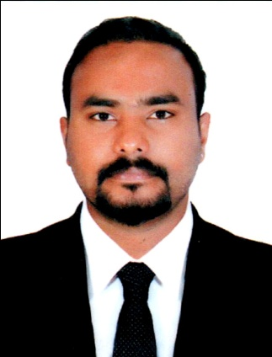
Cijo Sebastian
cijosebastian86@yahoo.com
Kerala, India
Mob: 0091-9846726322

Career Objective
Develop a career in an organization that provides motivation, has challenging work and when priorities require usage of skills and expertise to add value to company.

Career Experience
- Al - Mumtaz Trading and Contracting Company, Qatar (July 2009-February 2014) (Marketing Executive)
- The Style Factory (Multi Brand Factory Store), India (July 2014-January 2016) (Store Manager)
- Pinnacle Nissan Motor Works Private LTD, India (March 2016 – September 2017) (Team Leader)
- Saleh Al Hamad Al Mana Co. Nissan Showroom, P.O Box 91, Doha -State of Qatar (November 2017-February 2020) (Team Leader -Nissan Patrol)
Highlights
- Extensive vehicle knowledge.
- Familiar with financing options.
- Strong follow -up skills.
- Persuasive communicator.
- Competitive.
- Excellent negotiating tactics.
- Team player.
- Social media expertise.
- Advanced sales knowledge.
- Developing new sales strategies.
- Follow up with clients.
- Writes reports and time oriented.
- Product Demonstration.
- Public Speaking.
Career Summary
- Identifying potential customers, making offers, answering to inquiries, offering advice to hesitant clients and closing sales.
- Ability to effectively structure conversation to unveil the true needs of the customer and offer the right products.
- Executing problem solving skills to determine solutions for clients in escalated situations.
- Helping company to attain the highest customer service rating.
- Contributing to and developing marketing strategies and plans.
- Maintaining and updating customer databases.
- Analyzing and investigating price, demand and competition.
- Arranging effective distribution of marketing materials.
- Compiling and distributing financial information and managing budgets.
- Planning, advertising public relations, event organization, product development, distribution sponsorship and research.
- Communicating with target audiences and managing customer relationships.
- Exploring customer opinions and gaps in markets.
- Supporting market manager and colleagues.
- Liaising and networking with a range of stakeholders including customers, colleagues, suppliers and partner organizations.
- Reputation management.
- Convey policies and interest of the organization to the public.
- Plan to promote a new corporate move.
- Maintain cordial relation with potential client and media persons.
- Create an inspiring team environment with an open communication culture.
- Set sales targets and motivate sales team.
- Prepares and deliver sales report to management to report on team member performance and to improve mission related objectives if needed.
- Set clear team goals and delegate tasks to motivate team members.
- Monitor team performance and report on metrics to discover training needs and provide coaching.
- Help the team members for a qualitative and quantitative achievements of the team.
- Ensure effective time management.
- Establish effective organizational structure and communication protocols.
- Hires, motivates, train, counsels and monitors the performance of sales team.
- Directs and schedules the activities of team members.
- Implement a proper tracking and follow-up system.
- Maintain a high customer satisfaction rating.
- Communicates with sales team to ensure that dealership policies and procedures are understood and followed.
Key Strength
- Good teamwork skill.
- Good organization and planning skill.
- Drive, motivation, enthusiasm and creativity.
- Good communication skill.
- Confidence to ‘sell’ ideas and commercial awareness.
- Self motivated person.
- Ambitious, dedicated and adaptable.
- Energetic and enthusiastic.
- Trustworthy
- Courage and Integrity
- Cooperative and focused on goals.

Academics
- Xth from General Education Department, Govt. of Kerala, March 2002

- XIIth from Board of Higher Secondary Examination, Govt. of Kerala, March 2006.

- Bachelor of Commerce (B. Com) from Bundelkhand University, April 2009.

Technical Qualification

- Diploma in Hardware and Networking, June 2005
- Diploma in Fire and Safety Engineering, May2006

- IOSH (Institution of Occupational Safety and Health) June2016.

Additional course undertaken.
- Tally ERP 9
- MS Office

Personal Details

Born on 15th May 1986/ Male / Married/ Christian/ Indian

Linguistics : Malayalam, English, Tamil, Hindi & Arab

Passport Details
Number : H 8421886
Place of Issue : Doha

Licensed (India & Qatar) & Owned Car : 362016028111

Declaration

I hereby, assure you that the above furnished details are to the best of my knowledge and belief.
Truly Yours,
Cijo Sebastian

